**Background:**

We chose to study the relationship between divorce rate and unemployment. We chose this because:

* Relevance to our current situation – reading that divorce rates have gone up during COVID19
* We know that financial issues are typically the #1 listed cause of marital issues and/or divorce
* Since the COVID topic is currently covered exhaustively, we wanted to remove the COVID aspect, yet keep the concept of studying divorce rates
* When we originally googled this, previous research showed an inverse relationship in some cases which we thought was counterintuitive, we wanted to investigate further

**Source data:**

Divorce rates:

<https://www.cdc.gov/nchs/nvss/marriage-divorce.htm?CDC_AA_refVal=https%3A%2F%2Fwww.cdc.gov%2Fnchs%2Fmardiv.htm>

Unemployment data:

<https://data.bls.gov/timeseries/LNS14000000>

Screenshot:

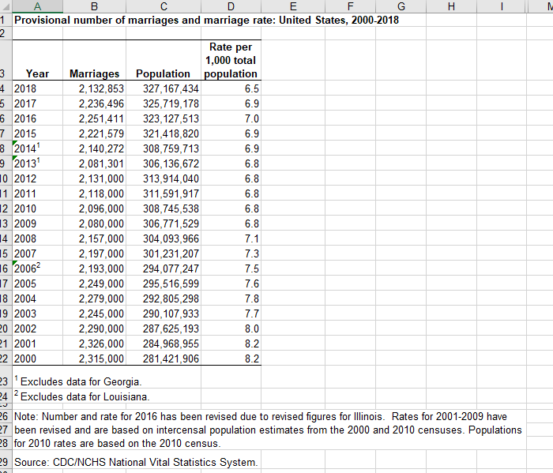

**Inspiration:**

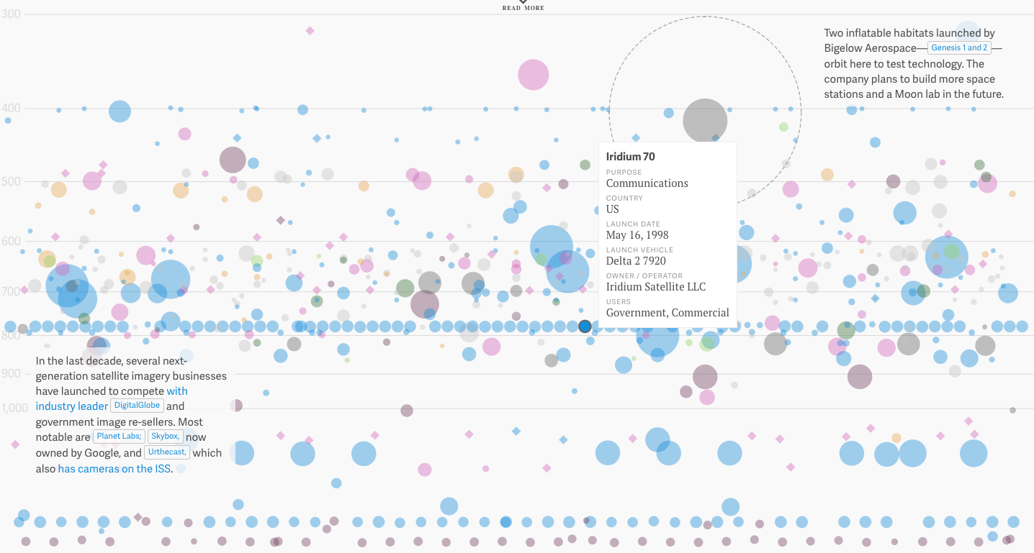

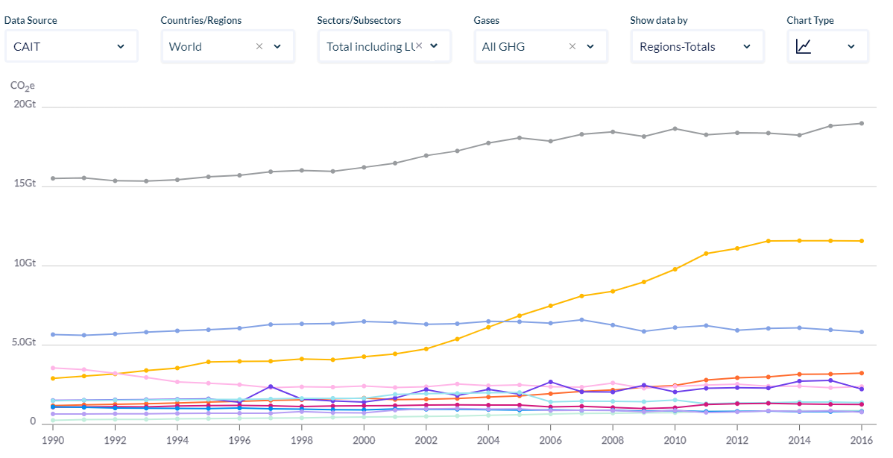

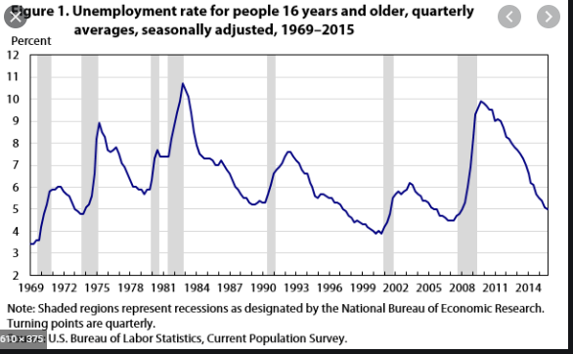

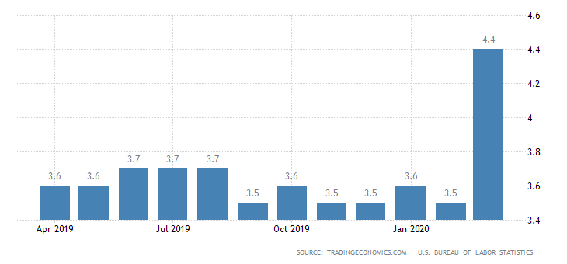

**Sketch:**

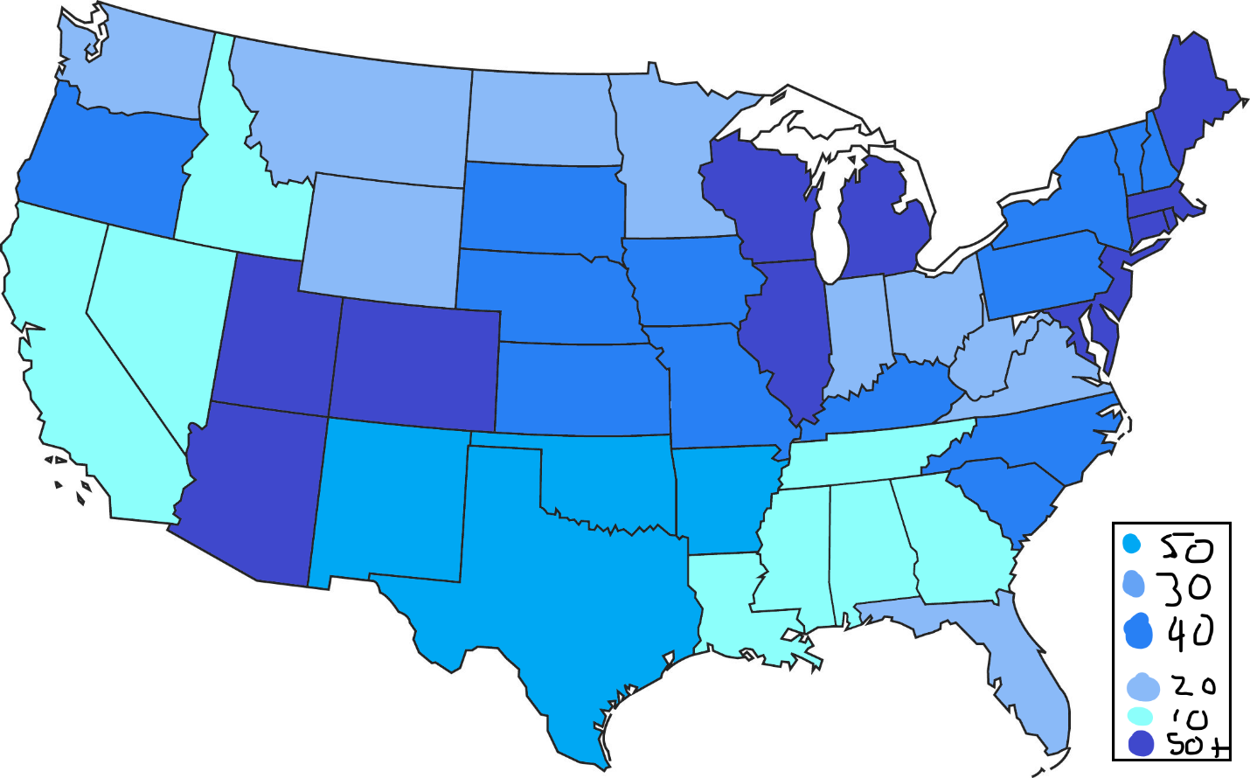

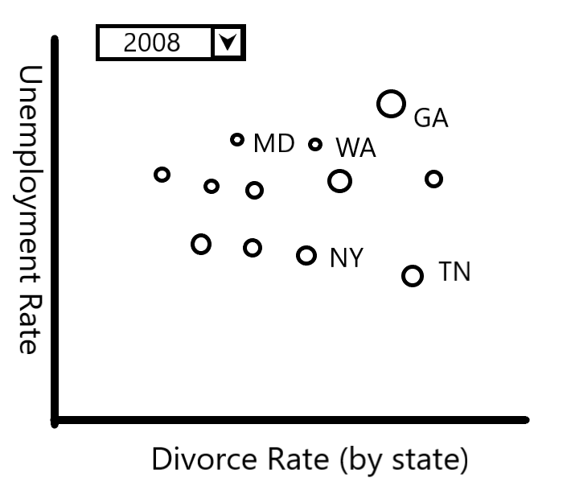

**GitHub Link:**

<https://github.com/ScriptMigo/Project-2>